The papers should be submitted as MS-Word documents adhering to the instructions for authors at this link. (Color figures can be used). There is no limit to the number of papers or the number of pages per paper.
Accepted Manuscript File Formats
Please submit your paper in MS Word (.doc or .docx) file format according to the detailed Manuscript Preparation Guides given below. The number of pages is at the discretion of authors; on average papers are 10-20 pages long. When preparing your paper for publication, we strongly advise that you pay particular attention to your research methods, key results and language. To ensure rapid review and publication, please adhere to these guidelines.
The first page of the manuscript should include:
a. Title of Manuscript
b. Names, addresses and email addresses of all authors
c. Name and complete address of the corresponding author
d. Abstract
Originality
Submissions must be original work, the copyright to which is not already owned elsewhere. Originality, creativity and a cross-disciplinary approach or perspectives are strongly encouraged. Significant duplication of papers and parallel submissions are not allowed. In such cases, the publisher reserves the right to withdraw publishing rights from authors and co-authors of the paper for a substantial period of time. It is the authors' responsibility to check for possible copyright conflict with the copyright holder and agree to our Publication Ethics and Publication Malpractice Statement.
Language
Given that the manuscript must be written in English, and if English is not the mother tongue of the author, we recommend that the paper should be proofread to ensure its accuracy and improve the language quality. The publisher can also provide copy editing service on payment.
Manuscript Preparation
General: Manuscripts must be typewritten, double spaced with ample margins on one side of white paper. The first page of a manuscript should include (a) Title of Manuscript (b) Names, addresses and email addresses of all co-authors (c) Name, complete address, telephone number, fax number and email address of the corresponding author (d) Abstract. An electronic copy of the paper should accompany that final version. The Editors reserve the right to adjust the style to specific standards for uniformity.
Paper Length: The Editors generally encourage brevity for all Research Papers. Short Communications must not exceed four printed pages and will be given priority for rapid publication.
Abstracts: Abstracts should not exceed 250 words, and should not contain a full reference.
Keywords: A minimum of 5 keywords must be included on a separate line below the main abstract and labelled as "Keywords". To optimise searching avoids keywords already used in the title. Avoid general and plural terms and multiple concepts (avoid, for example, 'and', 'of'). Be sparing with abbreviations: only abbreviations firmly established in the field may be eligible. These keywords will be used for indexing purposes.
Text: Follow this order when typing manuscripts: Title, Author, Affiliations, Abstract, Keywords, Text, Acknowledgment, Appendix, References, (Vitae if required –see below) Figure captions, and Tables. Do not import the Figures or Tables into your main text file in MS Word format. Provide a separate PDF file of your manuscript text with correct placement of figures and tables. The corresponding author should be identified with an asterisk and footnote. All other footnotes numerals (except for table footnotes) should be identified with superscript Arabic numbers.
Units: SI units. If other units are necessary, includes the conversion factor and add the non –standard unit in parenthesis.
Symbols: Define in text. Place an extensive list of symbols in appendix.
Math: Avoid double suffix. Punctuate carefully.
REFERENCES: References must be listed in the numerical system (Vancouver). All references should be numbered sequentially [in square brackets] in the text and listed in the same numerical order in the reference section. The reference numbers must be finalised, and the bibliography must be fully formatted before submission.
Journal titles are abbreviated (to decipher abbreviations see: PubMed Journals Database <http://www.ncbi.nlm.nih.gov/entrez/query.fcgi?db=journals>)
* Only first words of article title and words that usually begin with a capital letter are capitalised.
* If the journal has continuous page numbering, you may omit month/issue number
See below a few examples of references listed in the correct Vancouver style:
[1] Smith SD, Jones, AD. Organ donation. N Engl J Med 2001; 657: 230-5.
[2] Brown JG. Asphyxiation. Med J Aust 2003; 432:120-4.
Typical Chapter Reference:
[3] Blaxter PS, Farnsworth TP. Social health and class inequalities. In: Carter C, Peel JR, editors. Equalities and inequalities in health. 2nd ed. London: Academic Press 1976; p. 165-78.
Book Reference:
[4] Carlson BM. Human embryology and developmental biology. 3rd ed. St. Louis: Mosby; 2004.
Edited Book:
[5] Brown AM, Stubbs DW, Eds. Medical physiology. New York: Wiley 1983.
Conference Paper and Proceedings:
[6] Anderson JC. Current status of chorion villus biopsy. In: Tudenhope D, Chenoweth J, editors. Proceedings of the 4th Congress of the Australian Perinatal Society; 1986: Brisbane, Queensland: Australian Perinatal Society; 1987: p. 190-6.
[7] Harris AH, editor. Economics and health: 1997: Proceedings of the 19th Australian Conference of Health Economists; 1997: Sep 13-14; Sydney, Australia. Kensington, N.S.W.: School of Health Services Management, University of New South Wales; 1998.
Journal Article on the Internet:
[8] Aylin P, Bottle A, Jarman B, Elliott, P. Paediatric cardiac surgical mortality in England after Bristol: descriptive analysis of hospital episode statistics 1991-2002. BMJ [serial on the Internet]. 2004 Oct 9;[cited 2004 October 15]; 329:[about 10 screens]. Available from: http://bmj.bmjjournals.com/cgi/content/full/329/7470/825
Book/Monograph on the Internet:
[9] Donaldson MS, editor. Measuring the quality of health care [monograph on the Internet]. Washington: National Academy Press; 1999 [cited 2004 Oct 8]: Available from: http://legacy.netlibrary.com/
Web site/Homepage:
[10] HeartCentreOnline [homepage on the Internet]. Boca Raton, FL: HeartCentreOnline, Inc.; c2000-2004 [updated 2004 May 23; cited 2004 Oct 15]: Available from: http://www.heartcenteronline.com/
Journal with Part/Supplement:
If a journal carries continuous pagination throughout the volume, then the issue number can be omitted.
Issue with Supplement:
[11] Glauser TA. Integrating clinical trial data into clinical practice. Neurology 2002; 58(12 Suppl 7): S6-12.
Volume with Part:
[12] Abend SM, Kulish N. The psychoanalytic method from an epistemological viewpoint. Int J Psychoanal 2002; 83(Pt 2): 491-5.
Issue with Part:
[13] Ahrar K, Madoff DC, Gupta S, Wallace MJ, Price RE, Wright KC. Development of a large animal model for lung tumors. J VascIntervRadiol 2002; 13(9 Pt 1): 923-8.
Patent:
[14] Pagedas AC, inventor; Ancel Surgical R&D Inc., assignee. Flexible endoscopic grasping and cutting device and positioning tool assembly. United States patent US 20020103498. 2002 Aug.
E-citations:
[15] Citations for articles/material published exclusively online or in open access (free-to-view), must contain the exact Web addresses (URLs) at the end of the reference(s), except those posted on an author's Web site unless editorially essential, e.g. 'Reference: Available from: URL'.
Some important points to remember:
- All references must be complete and accurate.
- If the number of authors exceeds six, then "et al." will be used after three names (the term "et al." should be in italics).
- Online citations should include the date of access.
- Journal abbreviations should follow the Index Medicus/MEDLINE.
- Take special care of the punctuation convention as described in the examples as mentioned above.
- Avoid using superscript in the in-text citations and reference section.
- Abstracts, unpublished data and personal communications (which can only be included if prior permission has been obtained) should not be given in the reference section, but they may be mentioned in the text and details should be provided as footnotes.
- The authors are encouraged to use a recent version of EndNote (version 5 and above) or Reference Manager (version 10) when formatting their reference list, as this allows references to be automatically extracted.
Illustrations:
- All illustrations should be provided in the camera-ready form, suitable for reproduction (which may include reduction) without re-touching.
- All illustration must be readable when reduced to a width of 75 mm (single column figure) or 160 mm (double column figure).
- Photographs, charts and diagrams are all to be referred to as "Figure(s)" and should be numbered consecutively to which they are referred. They should accompany the manuscript but should not be included in the text.
- All illustrations should be clearly numbered. All figures are required to have a caption. Captionsshouldbesuppliedon a separatesheet.
Tables: Tables should be numbered consecutively, and each table typed on a separate sheet. Footnotes to tables should be typed below the tables and should be referred to by superscript lowercase letters. No vertical rules should be used. Tables should not duplicate result presented elsewhere in the manuscript (e.g. in the graph).
NEW COMPOSITE MATERIALS FOR ELECTROCHEMICAL PROTECTION OF PIPELINE SYSTEMS
Petrov S.I.¹
¹Ivanovo State University. 153025, Ivanovo, Russia
E-mail: petrov_si@gmail.com
Bernshtein K.²
²University of Hamburg. 20146, Hamburg, Germany
E-mail: BernshteinK@gmail.com
Abstract

Abstracts should not exceed 250 words, and should not contain a full reference.

Keywords: A minimum of 5 keywords must be included.

  - Introduction
Please submit your paper in MS Word (.doc or .docx) file format according to the detailed Manuscript Preparation Guides given below. The number of pages is at the discretion of authors; on average papers are 10-20 pages long. When preparing your paper for publication, we strongly advise that you pay particular attention to your research methods, key results and language. To ensure rapid review and publication, please adhere to these guidelines.
The first page of the manuscript should include:
a. Title of Manuscript
b. Names, addresses and email addresses of all authors
c. Name and complete address of the corresponding author
d. Abstract
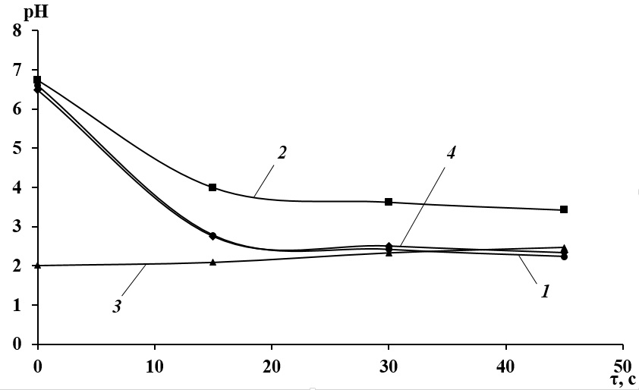
Fig. 1. Experimental data
References
[1] Smith SD, Jones, AD. Organ donation. N Engl J Med 2001; 657: 230-5.
[2] Harris AH, editor. Economics and health: 1997: Proceedings of the 19th Australian Conference of Health Economists; 1997: Sep 13-14; Sydney, Australia. Kensington, N.S.W.: School of Health Services Management, University of New South Wales; 1998.
[3] Anderson JC. Current status of chorion villus biopsy. In: Tudenhope D, Chenoweth J, editors. Proceedings of the 4th Congress of the Australian Perinatal Society; 1986: Brisbane, Queensland: Australian Perinatal Society; 1987: p. 190-6.

Corresponding author: Petrov S.I., Ivanovo State University. 153025, Ivanovo, Russia, E-mail: petrov_si@gmail.com

